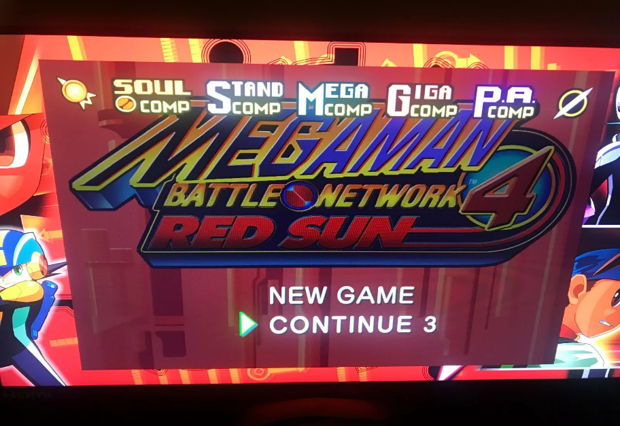

*Mega Man Battle NetWORK:*

1.**All 10 Versions of the 6 Main Games in One Collection**

* Includes **Mega Man Battle Network 1-6**, with both **dual versions** for **BN3, BN4, BN5, and BN6**.
* Features **story-driven RPG gameplay** with tactical grid-based battles.

2. **Enhanced Graphics & Optional HD Filters**

* **Smoother visuals** with an HD filter (toggle available for classic pixel look).
* **3D MegaMan.EXE model** in the menu as a virtual guide.

3. **Online Multiplayer Battles & Chip Trading**

* **PvP NetBattles** let players fight online in real-time battles.
* **Trade Battle Chips** with other players to complete collections.

4. **Buster MAX Mode (Casual Boost for Easy Playthroughs)**

* **Boosts MegaMan.EXE’s Buster power 100x**, making battles much easier.

5. **Massive Art & Music Collection**

* **Over 1,000 artworks** and designs from the series.
* **188 music tracks** from all six games in a dedicated music player.